Xamarin Fundamentals:

Module 3, Lesson 10  
Xamarin.Forms UWP Lab

Overview

First, attempt to use the [Lesson 9 Lab](https://github.com/MSFTImagine/computerscience/blob/master/Complimentary%20Course%20Content/Module3/Labs/Module%203%20Lesson%2009%20Xamarin.Forms%20Lab.docx) with UWP as the startup project. A Xamarin.Forms solution created with the Windows 10 SDK installed on the machine should automatically include a UWP project. Use this Lab when your existing Xamarin.Forms solution doesn’t have a UWP project.

Objectives

In this hands-on lab you will learn how to:

* Create and run a Universal Windows Platform (UWP) project in your Xamarin.Forms solution.

Prerequisites

The following are required to complete this hands-on lab:

* Completion of the [Module 3 Lesson 9 Lab](https://github.com/MSFTImagine/computerscience/blob/master/Complimentary%20Course%20Content/Module3/Labs/Module%203%20Lesson%2009%20Xamarin.Forms%20Lab.docx)
* Windows 10
* Visual Studio 2015
* Windows 10 SDK – download from Microsoft Windows Dev Center
* Xamarin.Forms 2.1+

Exercises

This hands-on lab includes the following exercises:

* Exercise 1: Creating a UWP project

Exercise 1: Creating a UWP Project

1. In Visual Studio’s NuGet Package Manager, select the “Upgrade available” filter and update all of your NuGets to Xamarin.Forms 2.0.
2. Create a Visual Studio Visual C#> Windows> Universal > Blank App (Universal Windows) Project.

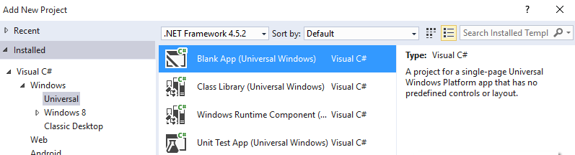

When you add the UWP project, it should look like this in the Solution Explorer:

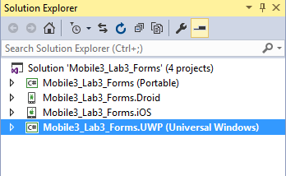

1. Right click on a project then Manage NuGet Packages... and add the Xamarin.Forms 2.0 package

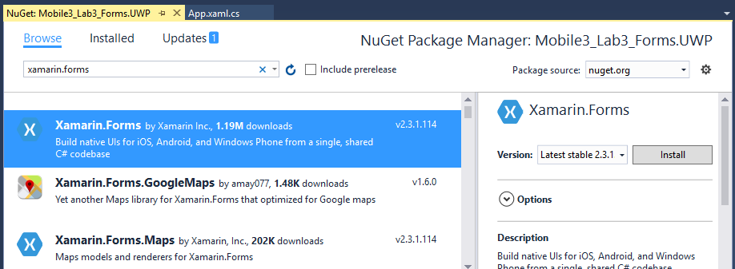

1. In the Build > Configuration Manager window, tick the Build and Deploy boxes for the Universal project:

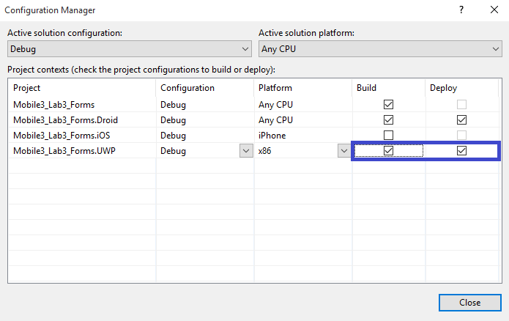

1. Add > Reference and create a project reference to the Xamarin.Forms application project (PCL or Shared Project)

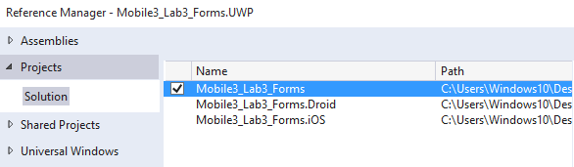

1. In App.xaml.cs OnLaunched method, after the following code:

rootFrame.NavigationFailed += OnNavigationFailed;

Add this Init statement:

Xamarin.Forms.Forms.Init (e);

1. In MainPage.xaml, add a new xmlns entry for Xamarin.Forms.Platform.UWP

xmlns:forms="using:Xamarin.Forms.Platform.UWP"

1. In MainPage.xaml, change the root element <Page to <forms:WindowsPage:
2. In MainPage.xaml.cs remove the :Page inheritance specifier for the class name

public sealed partial class MainPage // : Page

1. In the MainPage.xaml.cs constructor, after this line:

this.InitializeComponent();

Add the LoadApplication call:

LoadApplication(new YOUR_NAMESPACE.App());

1. If the project isn’t the active project (bolded), right-click the UWP project and select Set as StartUp Project.
2. In Debug/Run toolbar dropdown, choose Simulator
3. Compile and Run
4. This should bring you back to the end of the [Lesson 9 Lab](https://github.com/MSFTImagine/computerscience/blob/master/Complimentary%20Course%20Content/Module3/Labs/Module%203%20Lesson%2009%20Xamarin.Forms%20Lab.docx) but this time using your Windows desktop simulator running your UWP project.

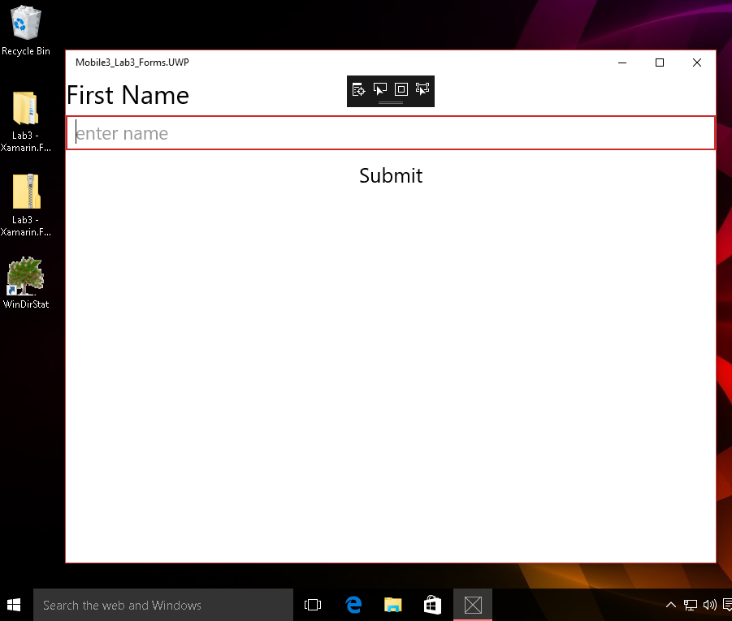

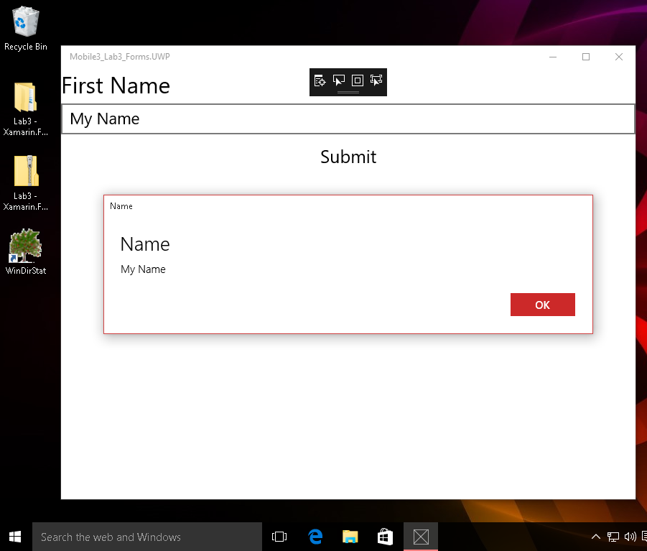

Hint: Hide the frame rate counter in the UWP simulator in App.xaml.cs by setting the EnableFrameRateCounter property to false.

Application.Current.Host.Settings.EnableFrameRateCounter = false;

Summary

In this hands-on lab, you learned how to:

* Create and run a Universal Windows Platform (UWP) project in your Xamarin.Forms solution.